Question 5 of Wireshark lab

1. Enabling the ftp server at kali.

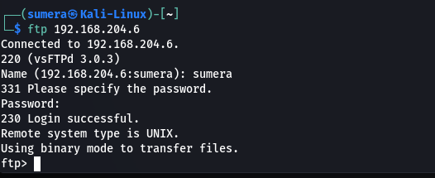

1. Access the server by user which is here windows 7.

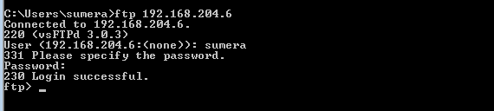

1. Wireshark at kali machine capturing the traffic.

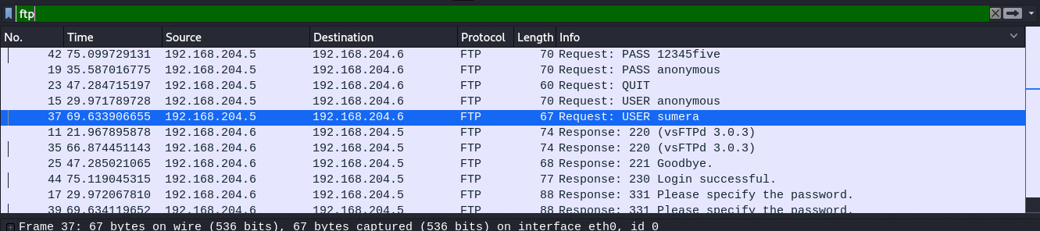

1. Captured password of user ( I have not enabled the anonymous login in server so only I can login with my user name and password.)

